3rd Grade Supply List 2024-2025
 | Quantity | Item
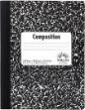 | 4 | Composition Books (wide-ruled; BLACK/WHITE marble, no spiral)
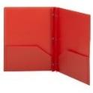 | 2 | Plastic folders blue and red
 | 1 | Folder (orange if possible) for ART
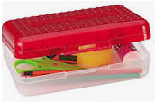 | 1 | Supply Box/Spacemaker Box
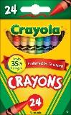 | 1 package | small pack of Crayola crayons (no bigger than 24 and no jumbo)
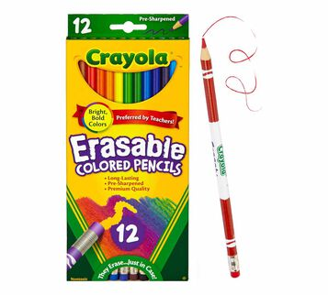 | 1 pack | small pack of colored pencils (12 count)
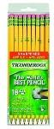 | 2 packages | Pre-sharpened #2 pencils, ticonderoga or target brand
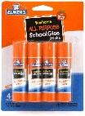 | 4 | Glue sticks
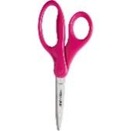 | 1 pair | - Child scissors (blunt tip)
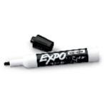 | 4 markers | Expo Dry Erase Marker (4-pack: black only)
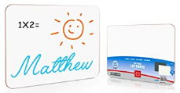 | 1 | Small Whiteboard (9x12)
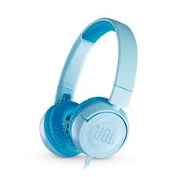 | 1 | headphones - no earbuds please
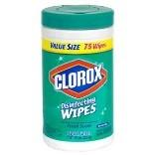 | 1 large canister | Clorox Wipes (75 wet wipes or larger)
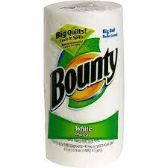 | 1 roll | Paper Towels
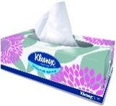 | 2 boxes | Kleenex tissues (family size)
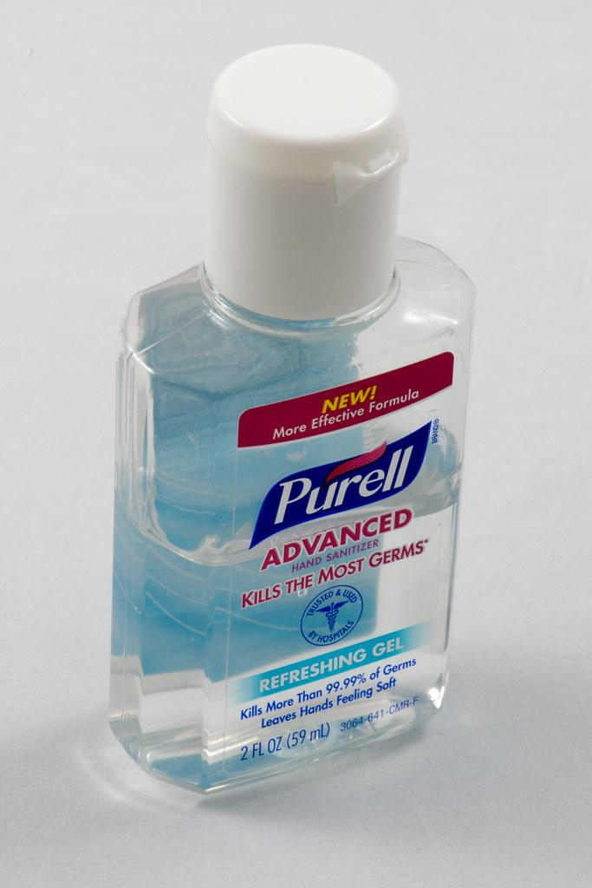 | 1 bottle | Hand Sanitizer
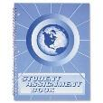 | 1 | Assignment book: purchase @ school store

